**SQL SERVER FUNCTIONS**

**1. All the work done by a celeb**

Create Function Fun_PersonWork(@PersonID int)

Returns Table

AS

Return(

select T.Title,TP.Role,CONCAT('TV','Show') as Category

from TvShows T

Join TvShows_Person TP

ON t.TvShowID=TP.TvShowID

Join Person P

ON P.PersonID=TP.PersonID

where P.PersonID=@PersonID

Union

select M.Title[Movie Title],MP.Role,CONCAT('Movie',' ') as Category

from Movies M

Join Movies_Person MP

ON M.MovieID=MP.MovieID

Join Person P

ON P.PersonID=MP.PersonID

where P.PersonID=@PersonID);

Sample Input Data

select * from Fun_PersonWork(11194)

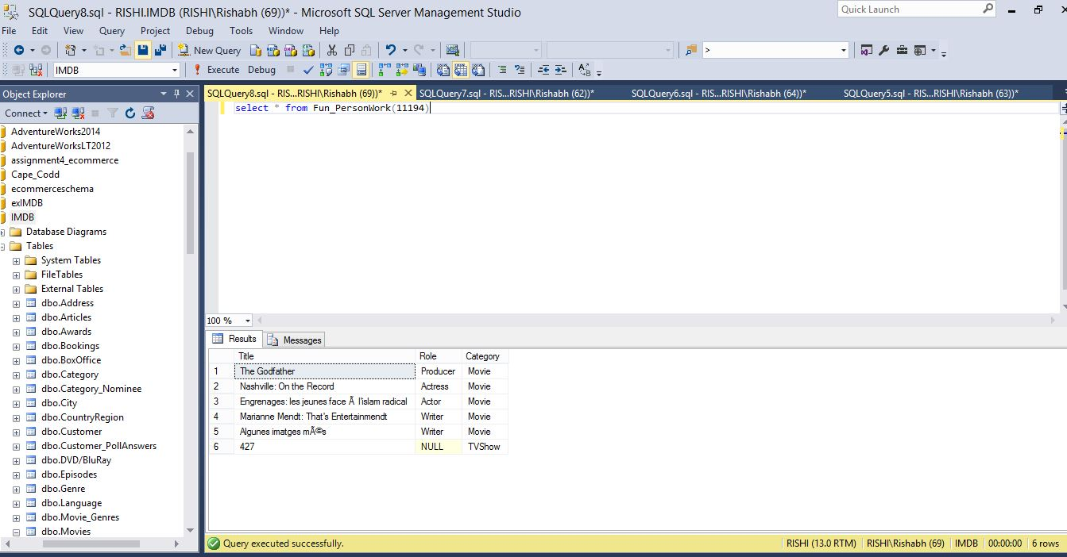

**2. Avg rating of a movie**

CREATE FUNCTION Fun_MovieAvgRating(@Title varchar(255))

RETURNS int

AS

BEGIN

DECLARE @ret int;

SELECT @ret = avg(R.Rating)

from Rating R

Join Movies M

ON R.MovieID=M.MovieID

where M.Title='Crush'

group by R.MovieID,M.Title

IF (@ret IS NULL)

SET @ret = 0;

RETURN @ret;

END;

Sample Input Data

select dbo.Fun_MovieAvgRating('crush')

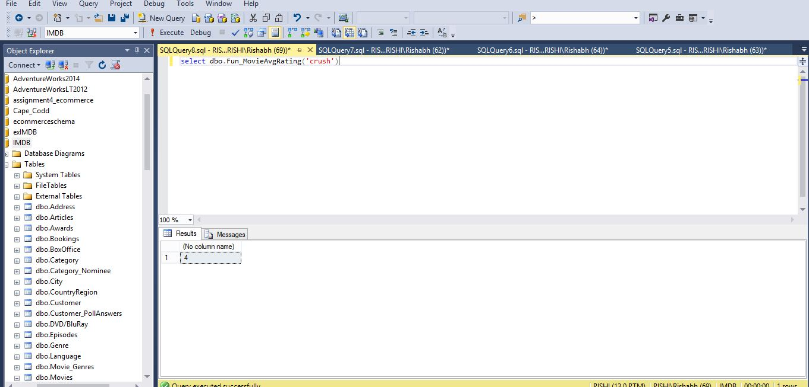

**3. Number of Votes for a particular Poll and its options**

Create Function Fun_PollDetails(@PollID int)

returns Table

AS

Return(

select P.Title,PO.PollOptions,count(*) as [Total Votes]

from Customer_PollAnswers CPA

join Polls P

on P.PollID=CPA.PollID

join PollOptions PO

ON PO.PollOptionsID=CPA.PollOptionsID

where P.PollID=@PollID

group by

grouping sets(PO.PollOptions,P.Title)

);

Sample Input Data

select * from Fun_PollDetails(2)

